THE POINTER CLUB

Report from The Breed Health Survey 2012
In collaboration with
The Pointer Club of Scotland
& The Northern Ireland Pointer Club

By: Jennifer Owen B.Vet. Med. MRCVS Published February 2013

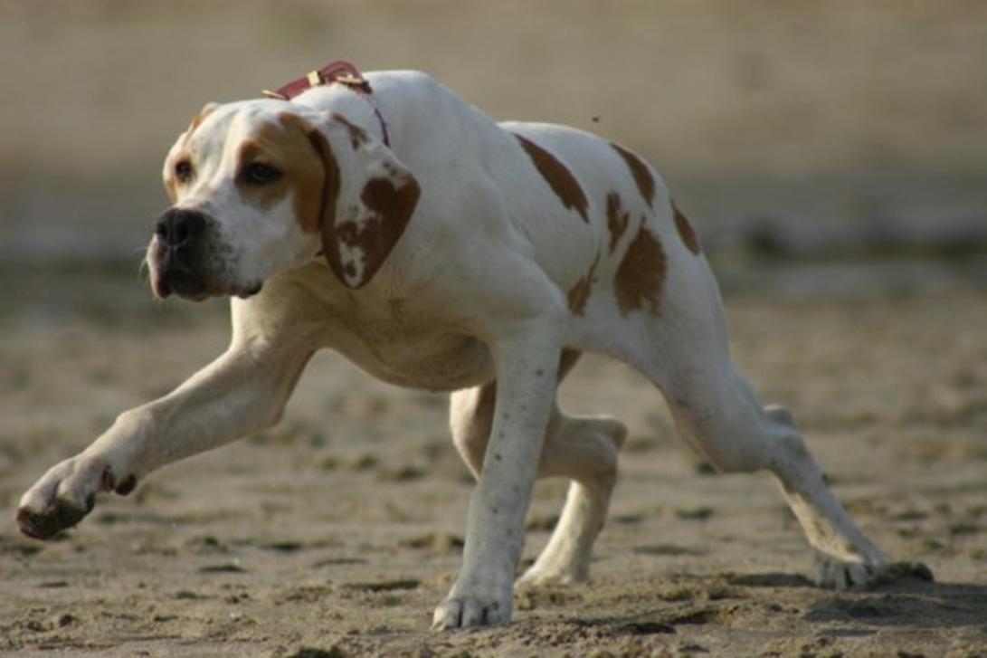

Hon Sec: Mrs Aidine Howes
Mandarin, Henley Road, Nuneham Courtenay, Oxfordshire, OX44 9PR
E Mail: jointhealth@thepointerclub.co.uk Tel: 01865 343435
Summary Results

Health survey forms were sent to Club members and other Pointer owners, these were also handed out at Crufts and Club shows. A total of 2,098 forms were distributed by the Joint Clubs, owners were also able to download further forms from the Pointer Club website.
99 of the survey forms returned were printed from the website and a further 34 were photocopied by owners.
A total of six hundred and forty survey forms were returned, representing 640 Pointers in the UK. Giving a total response rate of 31%.

Mortality data

A total of 182 deaths were reported. The mean age of death reported for Pointers was 10 years and 3 months (min 2 months, max 16 years). The table below shows the causes of death.

Cause of death No. % Most common specific causes in descending order
1 Old Age 43 23.6%
2 Cancer 41 22.0% Type unspecified
3 Musculoskeletal 17 9.3% Arthritis
4 Neurological 9 4.9% Seizures; Spinal disorders
5 Kidney Failure 9 4.9%
6 Cerebral Vascular 9 4.9% Stroke or cerebral vascular accident
7 Liver Failure 6 3.3%
8 Heart Disease 6 3.3%
9 Unknown 6 3.3%
10 Other 6 3.3%
11 Behaviour 5 2.7% Aggression
12 Endocrine 4 2.2% Addisons disease; Diabetes Insipidus
13 Poisoning 4 2.2%
14 Perioperative 4 2.2%
15 Respiratory disease 3 1.6% Laryngeal paralysis; Pneumonia
16 Immune mediated 3 1.6%
17 Trauma 2 1.1%
18 Gastric dilatation /
Volvulus 2 1.1%
19 Peritonitis 2 1.1%
20 Pyometra 2 1.1%

Histogram to show the frequency (as number of dogs) of age at death (in years) for the 179 dogs with age at death reported.

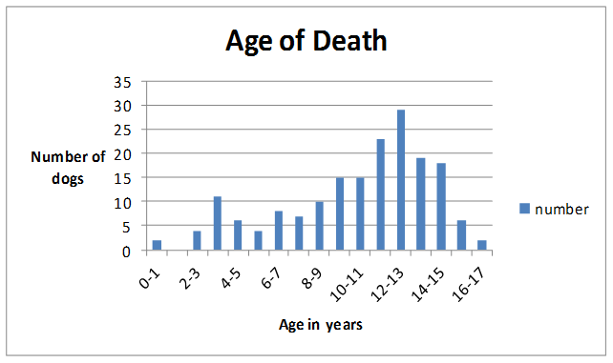

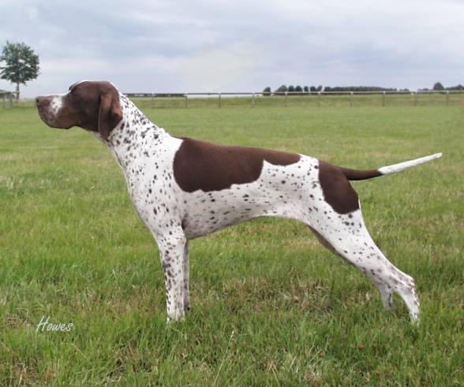
Morbidity Data

Health information was received on 640 dogs, 182 deceased and 458 living dogs. Of the living dogs 308 (67%) were healthy with no reported disease condition.
The results of the reported disease conditions are presented in the following table.

Disease Conditions by organ system/category

Disease condition No. % Most common specific conditions in descending order

1. Musculoskeletal 74 11.6% Arthritis; Spondylosis; Cruciate ligament; Unspecified
lameness; Fracture; Intervertebral disc disease; Osteochondrosis
2. Cancer 59 9.2% Unspecified; Mammary; Prostate; Liver; Lymphoma; Mast
cell; Osteosarcoma: Brain; Mandible; Thoracic; Gastrointestinal; Bladder
3. Dermatological 57 8.9% Allergy/Atopy; Dermatitis; Pyoderma; Alopecia
4. Reproductive 52 8.1% Caesarean; Pyometra; False Pregnancy; Mastitis; Infertility
5. Urologic 33 5.2% Kidney disease; Prostatitis; Cystitis; Incontinence;
Urolithiasisis
6. Gastrointestinal 30 4.7% Food allergy/sensitivity; Liver disease; Diarrhoea; Anal
sacculitis
7. Neurological 30 4.7% Seizures; Cerebrovascular accidents/ Stroke
8. Ocular 23 3.6% Cataracts; Conjunctivitis; Entropion; Corneal ulcer
9. Immune Mediated 18 2.8% Masticatory myositis; Haemolytic anaemia; Polyarthritis;
Myasthaenia gravis
10. Benign Lumps 17 2.7% Unspecified
11. Endocrine 14 2.2% Addison’s disease; Hypothyroid; Cushing’s; Diabetes
insipidus; Diabetes Mellitus
12. Others 12 1.9%
13. Trauma 10 1.6%
14. Cardiac 10 1.6% Heart murmur; Arrhythmia; Congestive heart failure
15. Respiratory 7 1.1% Laryngeal paralysis; Rhinitis; Pneumonia; Pleurisy
16. Aural 5 0.8% Otitis externa
17. Dental 4 0.6% Congenital defect; Dental disease
18. Unknown /
Undiagnosed 1 0.2%

Specific Health Survey Questions

Allergies

Allergies were reported in 67 dogs (10.5%). They were categorised as follows:

Skin 50 7.9%
Digestive 11 1.9%
Other 4 0.6%
Skin and digestive 2 0.3%

Temperament/ Behaviour Problems

Temperament/ behaviour problems were reported in 52 dogs (8.1%). They were divided up as follows:

Aggression 25 3.9%
Nervous 21 3.3%
Hyperactive 2 0.3%
Others 4 0.6%

Hormonal Disorders

Endocrine disorders were reported in 14 dogs (2.2%).

Addison’s disease (Hypoadrenocorticism) 6 0.94%
Hypothyroid 3 0.47%
Cushing’s disease (Hyperadrenocorticism) 2 0.31%
Diabetes Mellitus 1 0.16%
Diabetes Insipidus 1 0.16%
Reproductive hormone disorder 1 0.16%

Seizures

Seizures were reported in a total of 19 dogs (2.9%). They were classified as follows:

Idiopathic epilepsy 9 1.4%
Others/ undiagnosed 9 1.4%
Brain tumour 1 0.2%

The age of onset of idiopathic epilepsy ranged from less than 1 year to 6 years, with a mean of 2.6 years.

The Officers and Committee of The Pointer Club would like to thank the following for their help with this survey: The Kennel Club; The Officers and Committee of The Pointer Club of Scotland; The Officers and Committee of Pointer Club of Northern Ireland; Mrs Jennifer Owen B.Vet. Med. M.R.C.V.S. and Miss Gemma Taylor without whose input and dedication to our breed this survey would not have been possible. Also the Club Members who kindly gave their time to attend the preliminary meeting at the Kennel Club in January of 2012

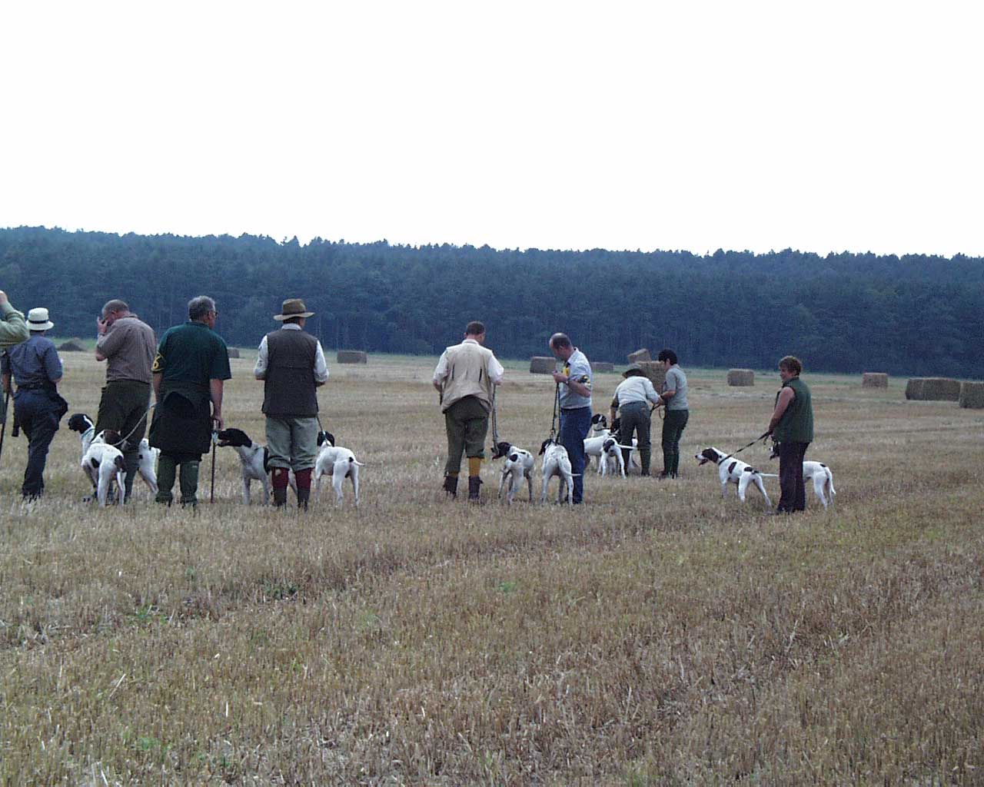

Photographic image copyright Stephanie Smith and Aidine Howes

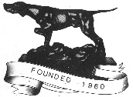 Copyright 2013 The Pointer Club

This booklet must not be reproduced, reprinted, electronically copied, photocopied or duplicated and must not be offered for sale. The booklet is for use solely by the Pointer club Health Committee and remains the copyright of The Pointer Club.

