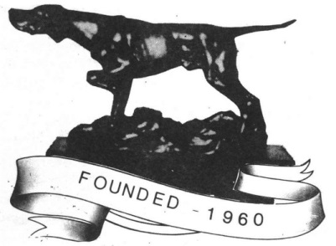

The Pointer Club Open Show
Points Trophy Award Winners 2021

These points are gained at the June and October Shows. There are two trophies, one for the individual dog or bitch gaining the most points at the two shows, and one for the breeder whose dogs gain the most points at both shows. Points 5,3,2,1 are awarded for the first four places.

Top Dog Awards June October Total
Norbury, Ganney & Adams:
Fisherbloom Hey Didle Didle at Norbury 10
Wilkinson:
Stocksfell Showdown 10
Weaver:
Dappleline Chance for Anniezu 8
Astbury:
Jilony Bobby Ball at Dorbury 8
Wheldon & Earl:
Caithpoint Kai 7
Blowers:
Fowington Lar Ti Dar at Deadaway 7
Tregaskis:
Moenfair Asteria Starshine 7

Top Breeder Award
Hawkfield: 22
Millpoint: - 19
Fisherbloom: 15
Stocksfell: 12
Tenshilling: Sharnphilly: Moenfair: 11

Well done to the winners who have been calculated by publications editor Trish Eldridge.

